Sales and Distribution
SD Part 2 LAB BOOK

Table of Contents
Table of Contents 2
Lab 1-1 Create a Return Sales Order w.r.t. Normal Sales Order->Returns Delivery->Credit Memo (Billing) 3
Lab 2-1 Create a Cash Sales->PGI->Billing 7
Lab 3-1 Create a Rush Order->Picking and PGI->Billing 10
Lab 4-1 Create a Service Material (MAT-TYPE-DIEN) 13
Lab 5-1 Create a Sevice Contract->Change Billing Plan->Create Billing 16
Lab 6-1 Create a Credit Customer-BP 19
Lab 7-1 Create Item Proposal with 2 items->Create a Sales Order->Create 2 deliveries>Collective Billing 22
Lab 8-1 Setup a Credit Memo Scenario 26
Lab 9-1 Setup up Partner Determination Z# in BP and Normal Sales Order 28
Lab 10-1 Setup Output Determination for Normal Sales Order 29
Lab 11-1 Setup Text Determination in Normal Sales Order 30
Lab 12-1 Create Incompletion Procedure and remove the Net Weight/Gross weight/Incoterms/Payterms from resp. Sales Order 31
Lab 13-1 Create a Material Determination scenario in Sales Order 32
Lab 14-1 Create Free Goods Scenario in Sales Order 34
Lab 15-1 Create a Cross Selling Scenario with Sales Order->Delivery->Split Invoice 37
Lab 16-1 Create a New Availability Check Group->Assign to Material Master->Create Sales Order->Delivery 41
Lab 17-1 Create process flow-CF->CI->CR-CP 43
Lab 18-1 Normal Sales order (Optional)->Returns->Subsequent Deivery (type-SD)->Delivery 46
Lab 19-1 Create a 3rd Party Sales Order->Purchase Order->GR 48

Lab 1-1 Create a Return Sales Order w.r.t. Normal Sales Order->Returns Delivery->Credit Memo (Billing)
1.1 Create Return Order
Sales Department can create return order by T-code VA01. Return order can be created with reference to sales order or billing documents.
Step 1)
- Enter T-code VA01 in command field.
- Enter Order Type RE (Returns).
- Enter Sales Area data in Organizational Data Block.
- Click on Create with Reference Button.
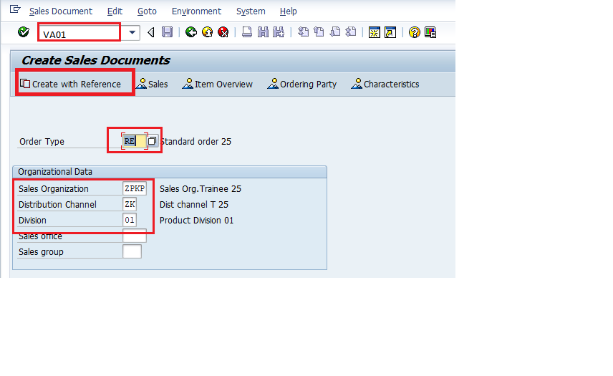
Step 2)
- Enter Sales order # reference no. for return order.
- Click on Copy Button
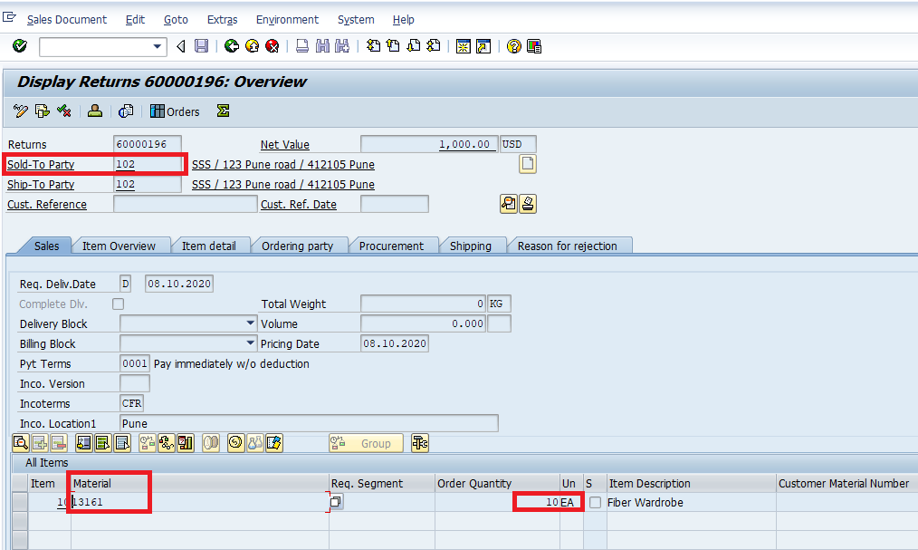

Step 3)
- Enter Order reason .
- Enter Ordered Quantity.
- Remove Billing Block.

Step 4)
- Check Incompletion log
- Click on save button.
- Copy the Order number for further reference.
1.2 Create Return Delivery Document
Step 1)
- Enter T-code VL01N in command field.
- Enter Shipping Point.
- Enter Delivery Type LR (Return Delivery).
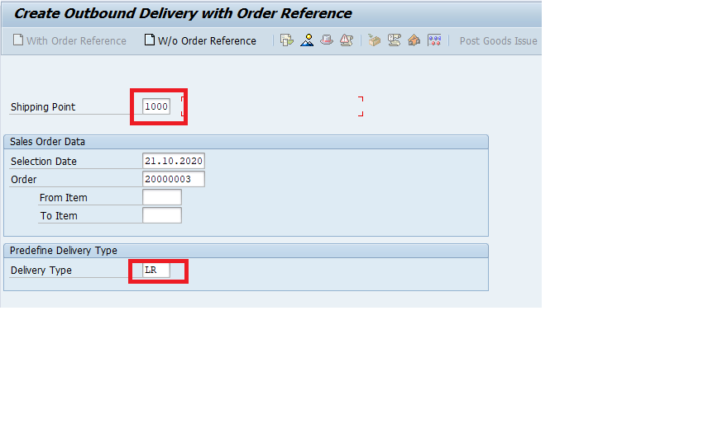
- Press Enter Button.
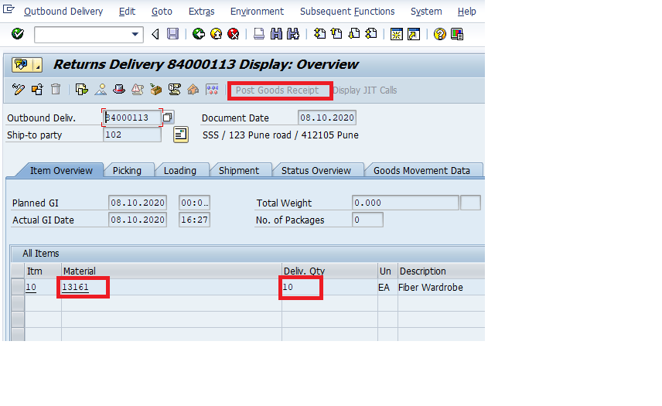
Step 2)
- Enter Return Delivery Quantity.
Step 3)
- Click on save button.
- Copy the Order number for further reference.
1.3 Create Billing Document

- Enter T-code VF01 in command field.
- Enter the Order number.
- Press Enter Button.

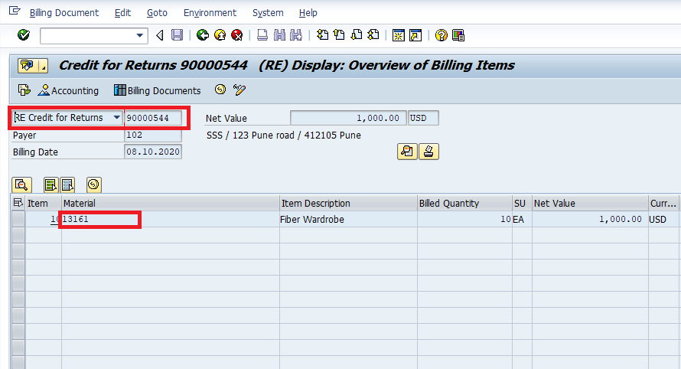

1.4 Create Credit Memo
Step 1)
- Enter T-code VA01 in command field.
- Enter order type field value as credit memo request .
- Enter Sales Organization / Distribution Channel / Division in Organizational Data.
- Click on Create with References Button.
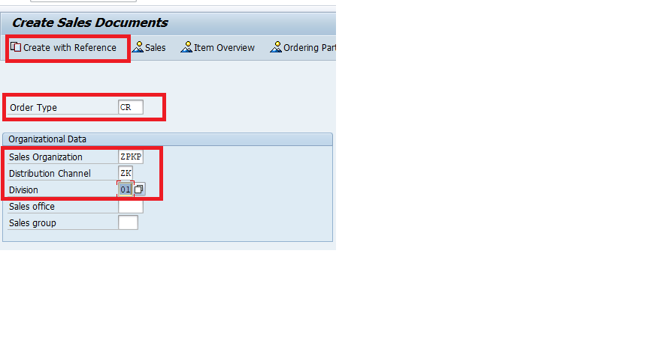

Step 2)
- Enter order no in Order tab of Pop Up.
- Click on Copy Button.

Step 3)
- Enter Billing Block / Pricing Date / Order Reason and Billing Date in sales tab.
- Enter Material and Quantity for which we want to create Credit Memo.

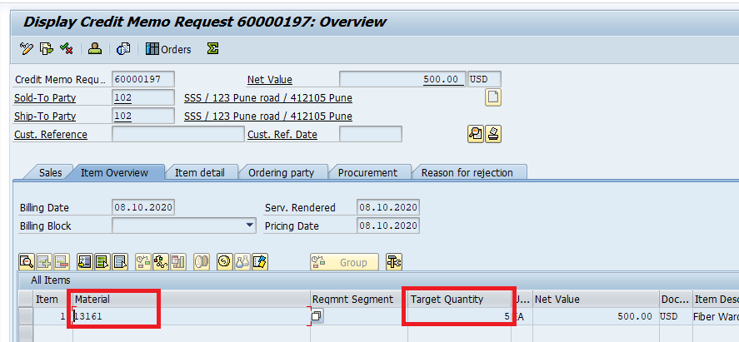

Step 4)
- Click on Save Button .

Lab 2-1 Create a Cash Sales->PGI->Billing
1.1 Create a Cash Sales

Step 1)
- Enter T-code VA01 in command field.
- Enter Order Type BV (Cash Sales).
- Enter Sales Area data in Organizational Data Block.
- Press Enter Button.

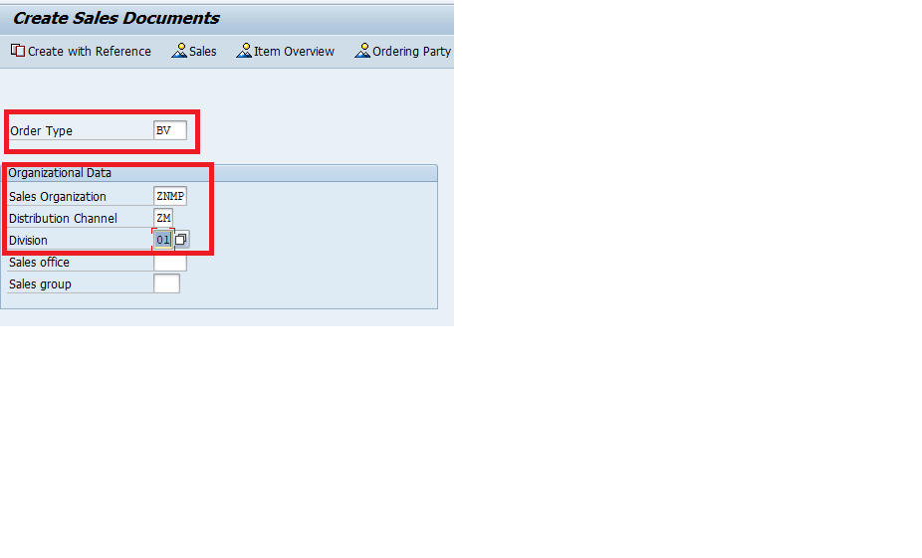
Step 2)
- Enter the Sold-to-party, Material, Order Qty
- Check the incompletion log
- Click on Save Button and copy Delivery no.
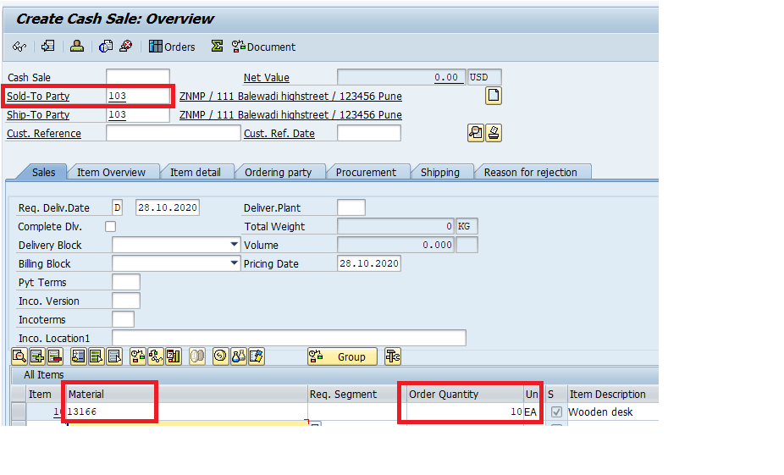

1.2 Delivery- Post goods issue

Step 1)
- Enter T-code VL02N in command field.
- Enter the delivery no.
- Press Enter button
- Click on Post Goods Issue (PGI)

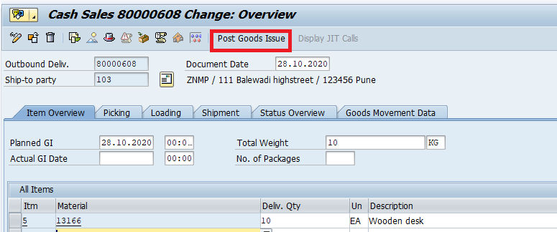

1.3 Billing

Step 1)
- Enter T-code VF01 in command field.
- Enter the Cash sales document no.
- Press Enter button
- Click on Save

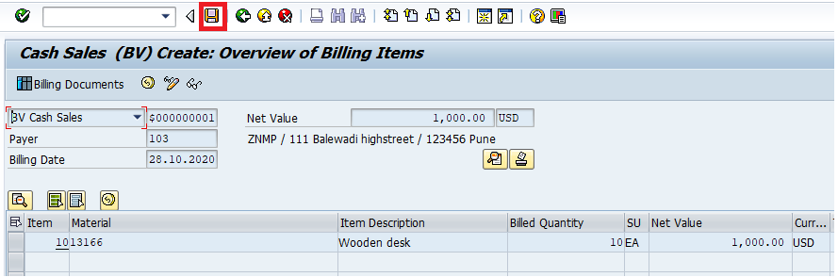

To Check the document>>> T-code VA02>> Click on Document flow

Lab 3-1 Create a Rush Order->Picking and PGI->Billing
1.1 Create a Cash Sales

Step 1)
- Enter T-code VA01 in command field.
- Enter Order Type SO (Rush Order).
- Enter Sales Area data in Organizational Data Block.
- Press Enter Button.
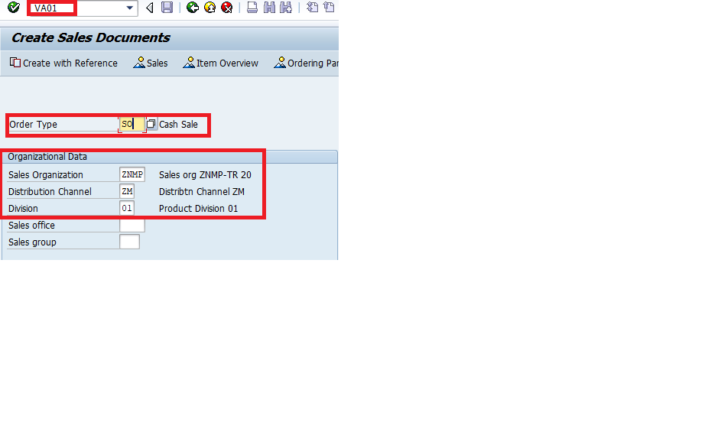

Step 2)
- Enter the Sold-to-party, Material, Order Qty
- Check the incompletion log
- Click on Save Button and copy Delivery no.
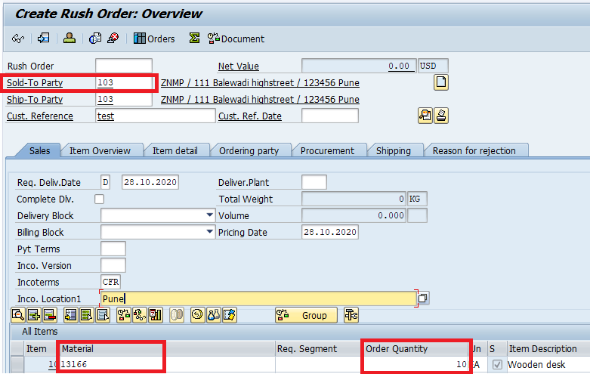

1.2 Delivery- Picking and Post goods issue
Step 1)
- Enter T-code VL02N in command field.
- Enter the delivery no.
- Press Enter button
- Go to Picking tab>>> Enter Picked Qty
- Click on Post Goods Issue (PGI)

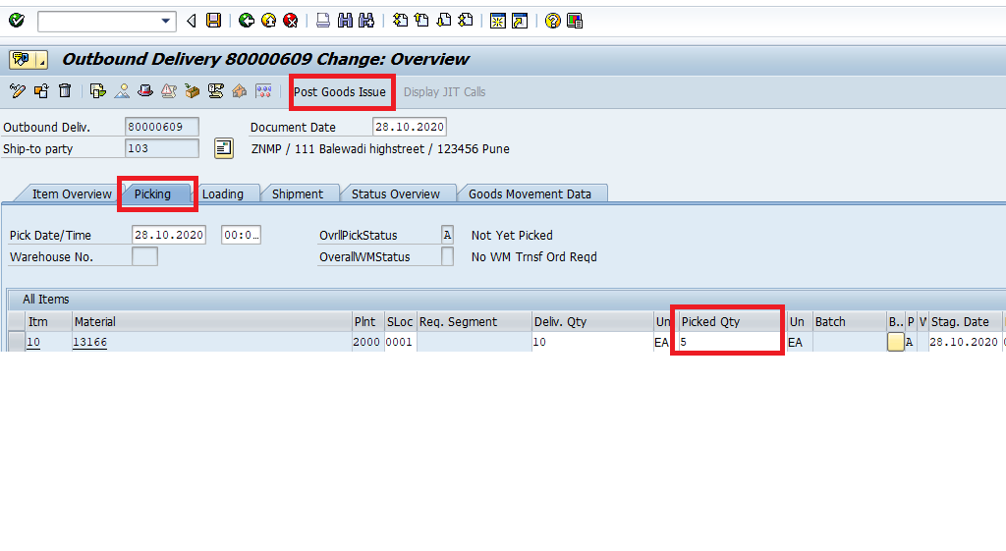

1.3 Billing
Step 1)
- Enter T-code VF01 in command field.
- Enter the Cash sales document no.
- Press Enter button
- Click on Save

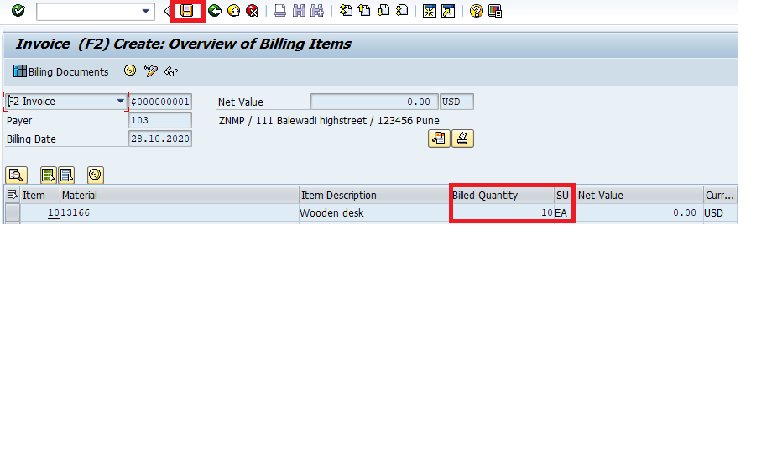

To Check the document>>> T-code VA02>> Click on Document flow

Lab 4-1 Create a Service Material (MAT-TYPE-DIEN)
Step 1)
- Enter T-code MM01 in command field and create a new material
- Enter Material type as DIEN (Service Material)>>> Select Industry sector as Retail>>> Press Enter
- Select view as 1) Basic data 2) Sales: Sales org data 3) Sales: General/Plant 4) MRP1 5) MRP2

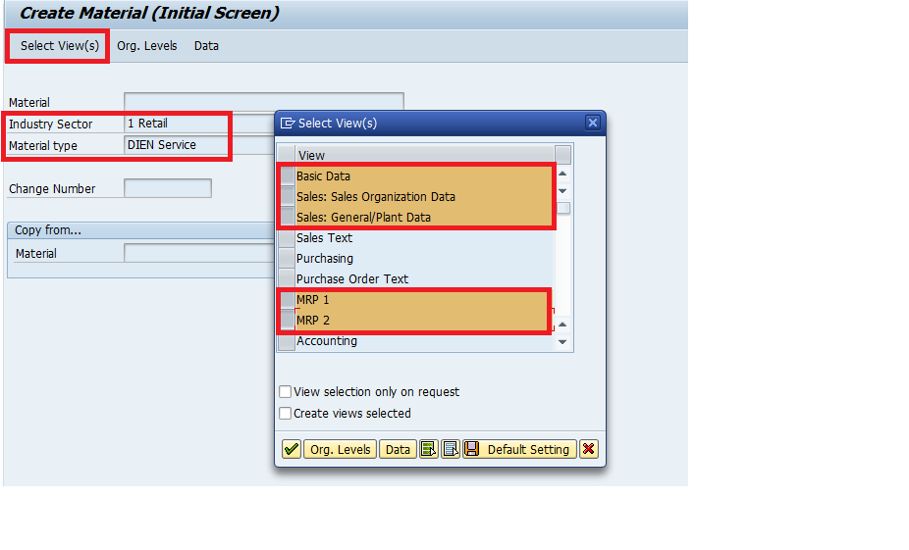

Step 2)
- Enter Plant/ Storage location/ Sales org/ Dist. Channel
- Press Enter
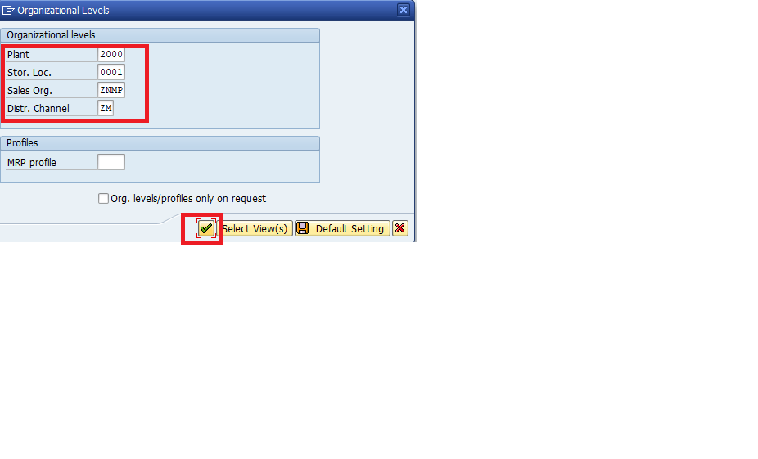

Step 3)

Screen 1: Enter the Material description/ Base Unit

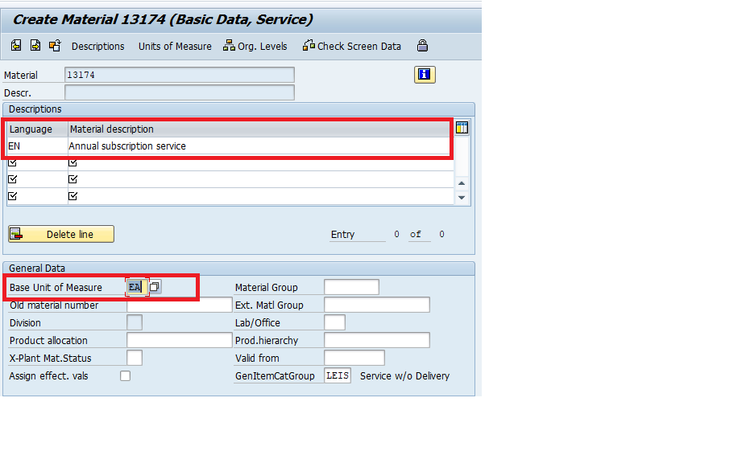

Screen 2: Enter Tax
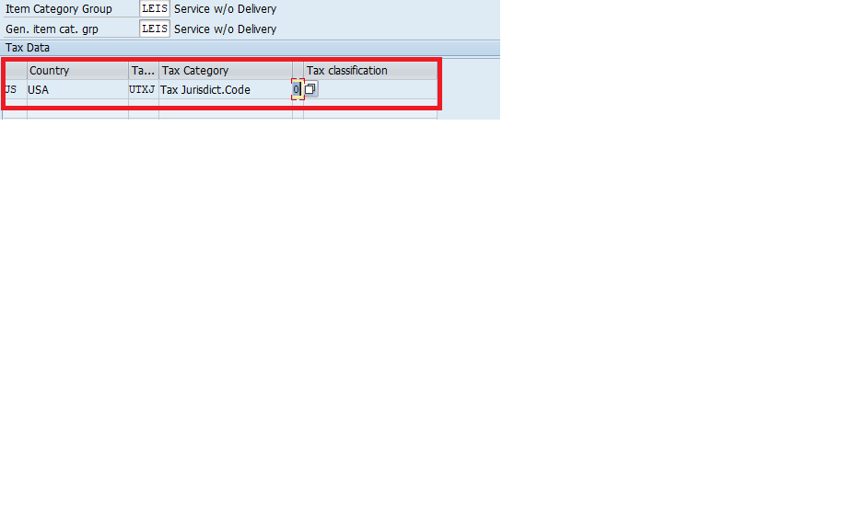

Screen 3: Enter Purchasing Group/ MRP Type/ Planned Delivery time

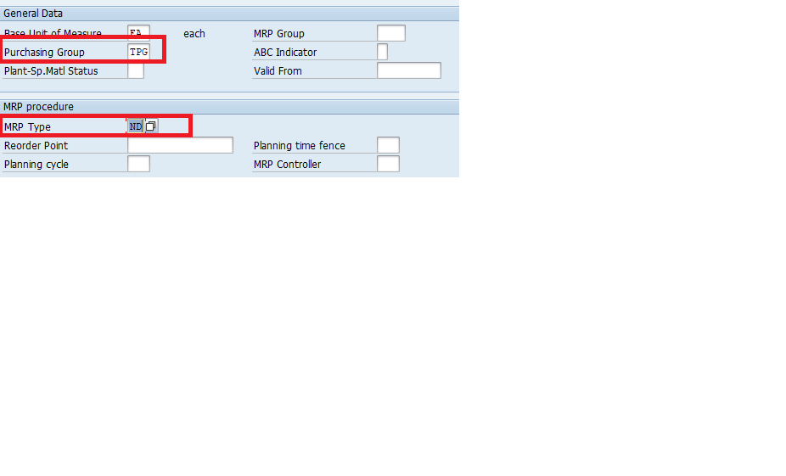

Click on Save and Copy the service material no.

Lab 5-1 Create a Sevice Contract->Change Billing Plan->Create Billing
  - Create a Sevice Contract
Step 1)
- Enter T-code VA41 (Create Contract) command field OR
SAP Easy access>>>SAP Menu>>>Logistics>>>Sales & distribution>>>Sales>>>Contracts>>>Create
- Enter Order Type WV (Service & Maint).
- Enter Sales Area data in Organizational Data Block.
- Press Enter Button.
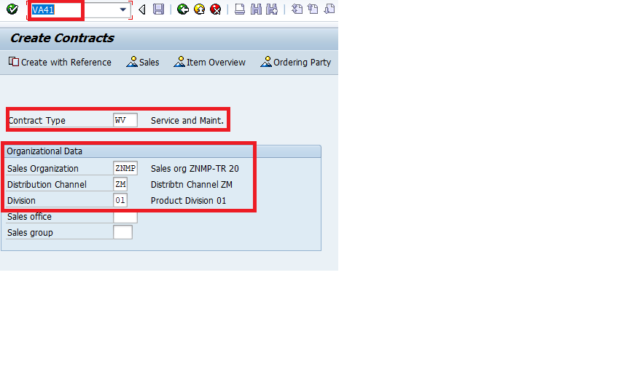

Step 2)
- Enter the Sold-to-party, Material, Target Qty, Enter Cotract end date, Enter Acceptance date rule (eg 04)
- Check Item Categaory as WVN
- Click on Save Button and copy the Service & Maint. No.
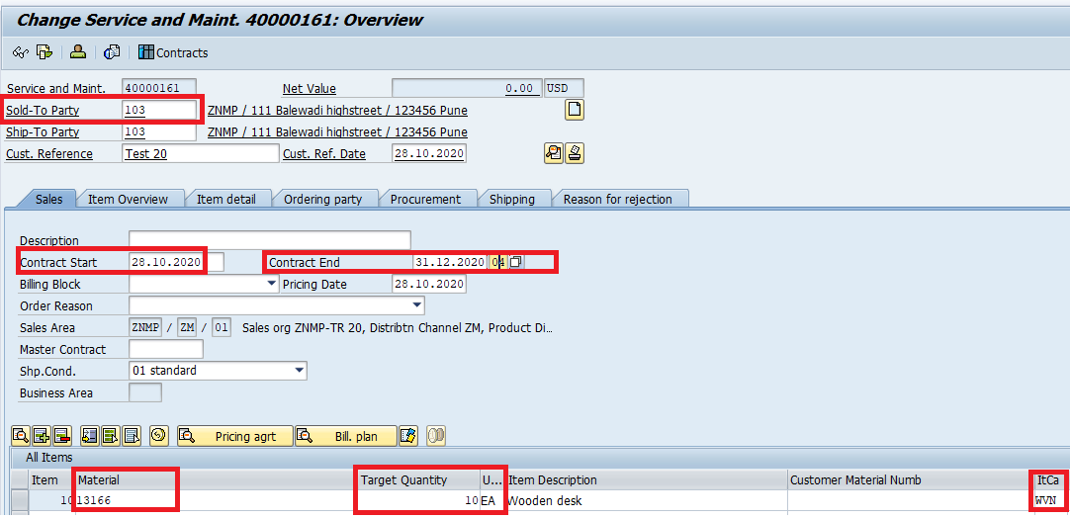
1.2 Change Billing Plan
Step 1)
- Enter T-code VA42 command field.>>>Enter the contract no.>>Select the line item & Click on the Billing Plan
- Change the date: Enter Dates until
- Press Enter and Click on Save
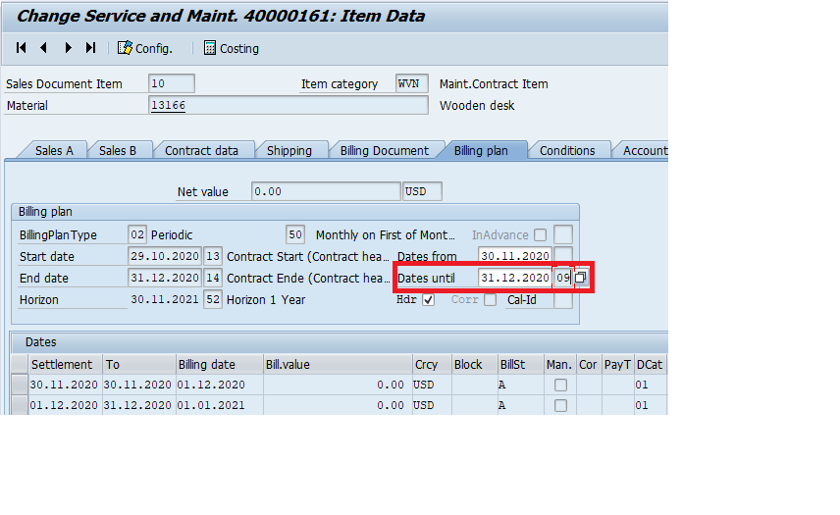

  - Create Billing

Step 1)
- Enter T-code VF01 in command field.
- Enter the document no. of Service & Maint.
- Press Enter button
- Click on Save
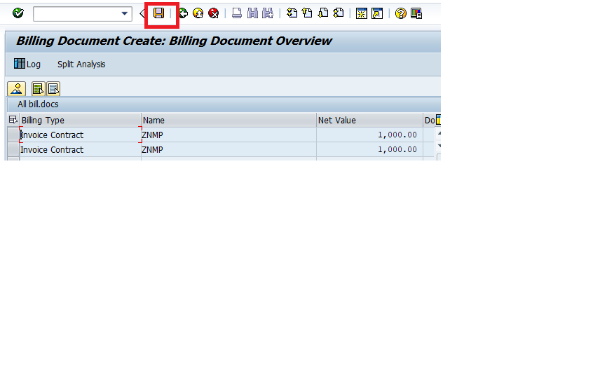

To Check the document>>> T-code VA02>> Click on Document flow

Lab 6-1 Create a Credit Customer-BP
Step 1)
- Enter T-code BP in command field.
- Enter the Customer no.
- Press Enter
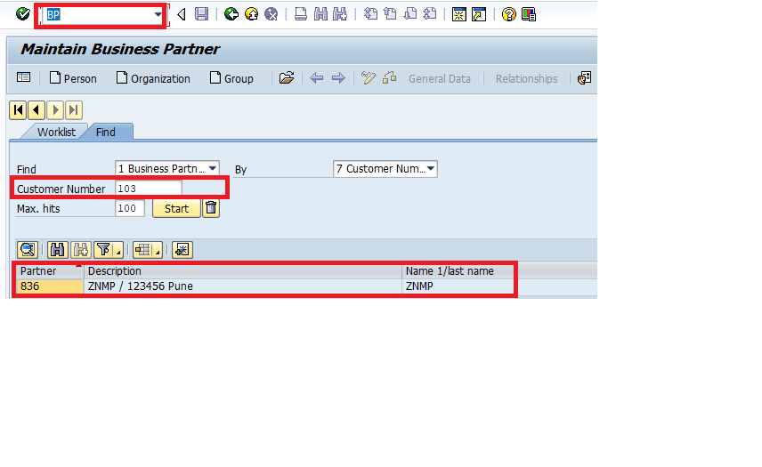
Step 2)
- Go to change mode
- Add one more role to your existing BP- UKM000 SAP Credit Mgt.
- Go to Credit Profile>>>Rules>>>Date- Valid to>>>Risk Class>>>Check Rule>>>Credit Group
- Enter Rating Procedure>>>Rating>>>Trend
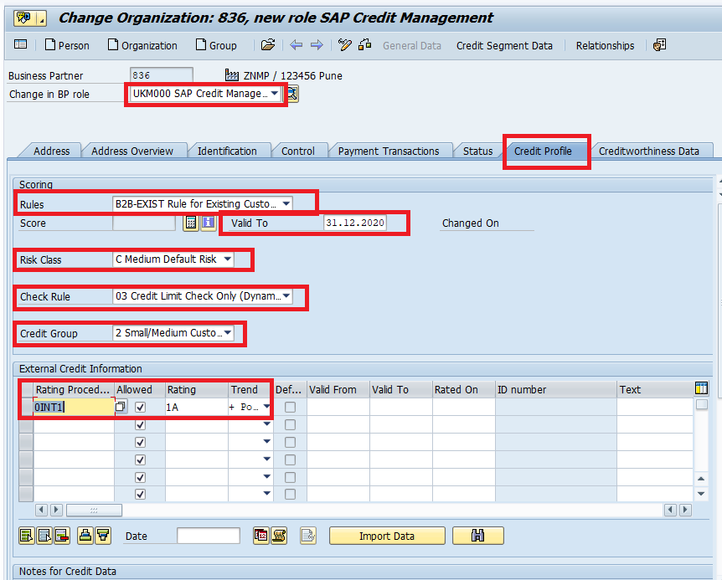

Step 3)
- Go to Creditworthiness data>>>Credit Standing

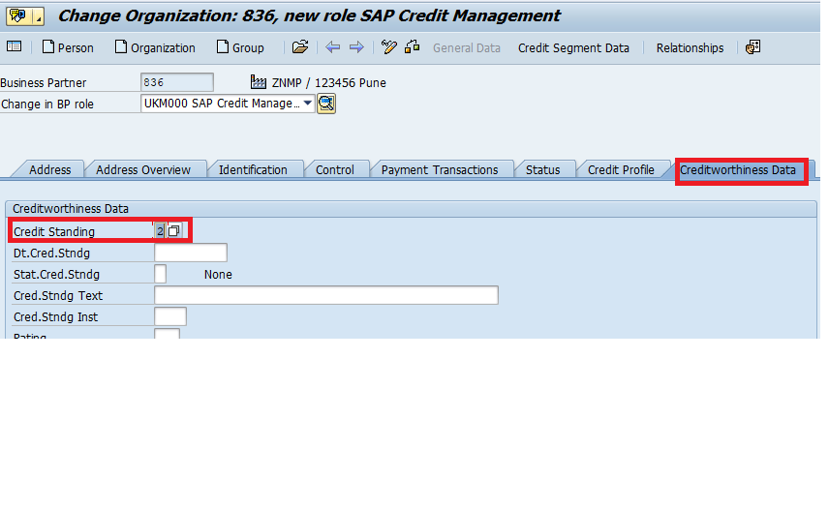

Step 4)
- Go to Credit Segament data
- Credit Segment>>>Rule>>>Limit defined>>>Enter Limit>>>Enter Valid to date
- Click on Save

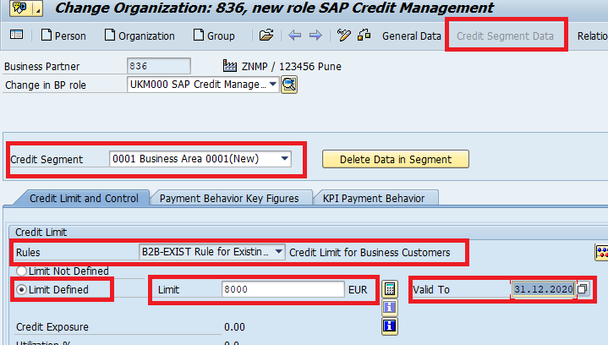

Lab 7-1 Create Item Proposal with 2 items->Create a Sales Order->Create 2 deliveries>Collective Billing
  - Create Item Proposal with 2 items
Step 1)
- Enter T-code VA51 (Create Item Proposal) command field OR
SAP Easy access>>>SAP Menu>>>Logistics>>>Sales & distribution>>>Master data>>>Products>>>Item Proposal>>>Create
- Enter Order Type PV (Item Proposal).
- Enter Sales Area data in Organizational Data Block.
- Press Enter Button.
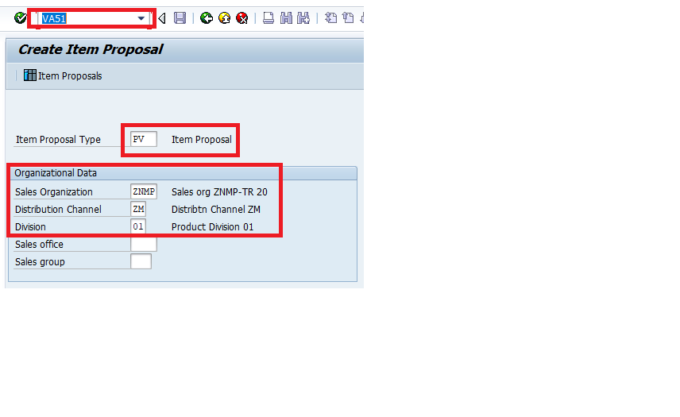

Step 2)
- Enter the description>>>Valid from; Valid to date
- Enter 1st Material>>>Qty
- Enter 2nd Material>>>Qty
- Click on Save and copy the Item Proposal no.

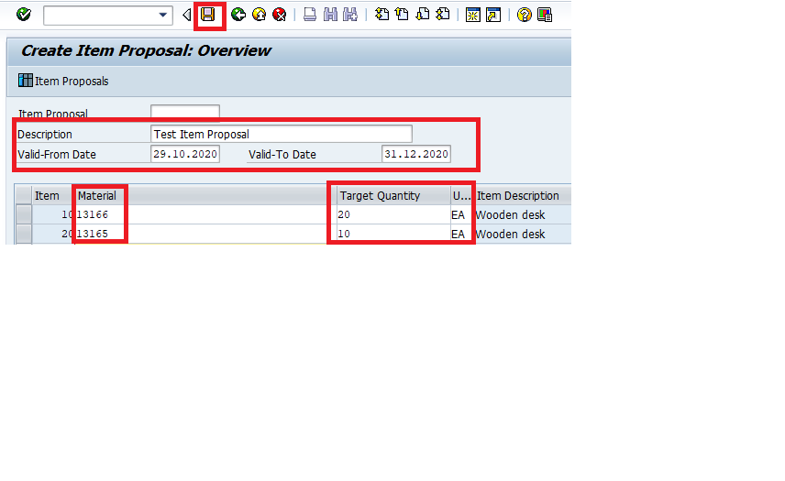
Step 3)
- Enter the T-code BP in the command field
- Enter Customer no.>>>Display mode>>>Customer Role>>> Sales & Distribution tab>>>Go to change mode>>>Enter the Item Proposal no.
- Save it
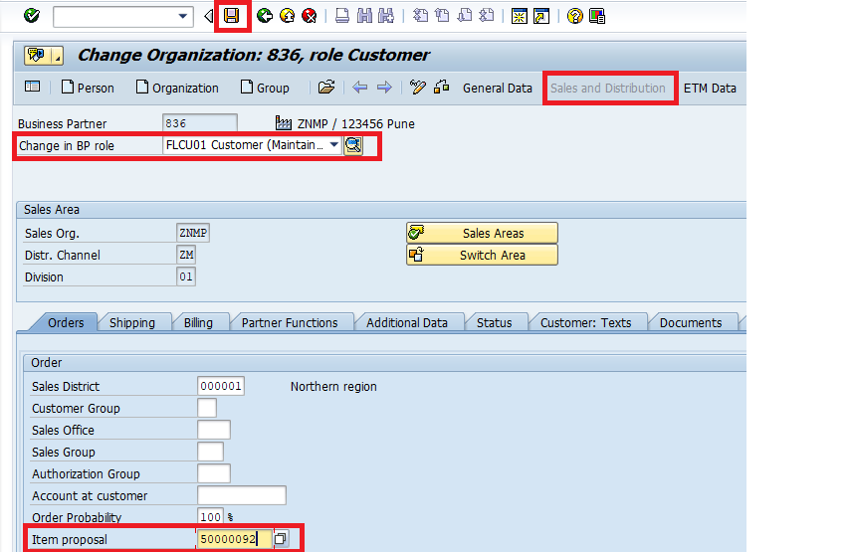

  - Create a Sales Order
Step 1)
- Enter the T-code VA01 in the command field
- Enter Order Type (the one you have created in SPRO)
- Enter Sales Area data in Organizational Data Block.
- Press Enter Button
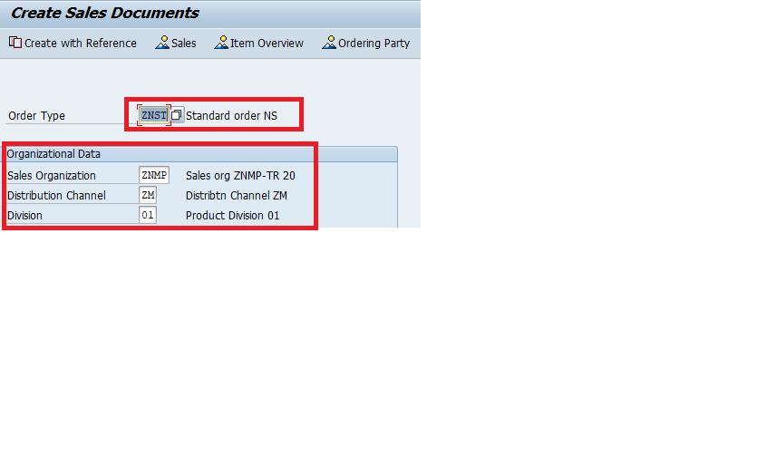

Step 2)
- Click on Propose Item>>>Proposal will come automatically>>>Dafault with quantity
- Complete the document and check the incompletion log
- Click on Save

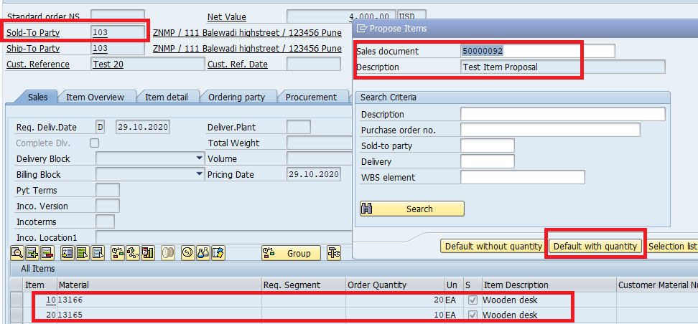

  - Create 2 deliveries using VL01N

Step 1)
- Enter T-code VL01N in command field.
- Enter the shipping point and order no.>>>Select the first item
- Press Enter button

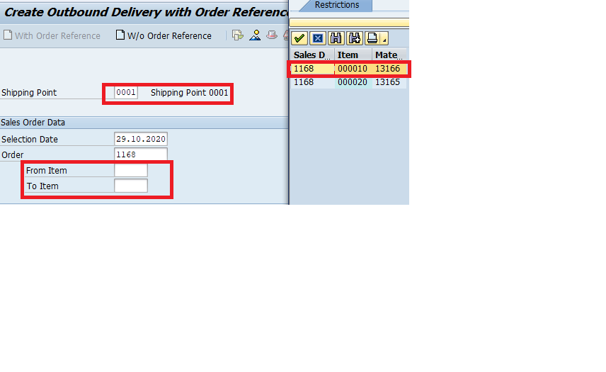
Step 2)
- Picking >>>Post goods Issue (PGI)
- Repeat the same steps for second item also

  - Collective Billing

Step 1)
- Enter T-code VF04 in command field.
- Enter Billing Date From>>>Display billing list
- Select the two line item that you created and Click on Collective billing document

To Check the document>>> T-code VA02>> Click on Document flow

Lab 8-1 Setup a Credit Memo Scenario
Step 1)
- Create a sales Order using the T-Code VA01
- Order type as CR (Credit Memo Request)
- Enter Sales Area data in Organizational Data Block.
- Click on create with refrence with billing document
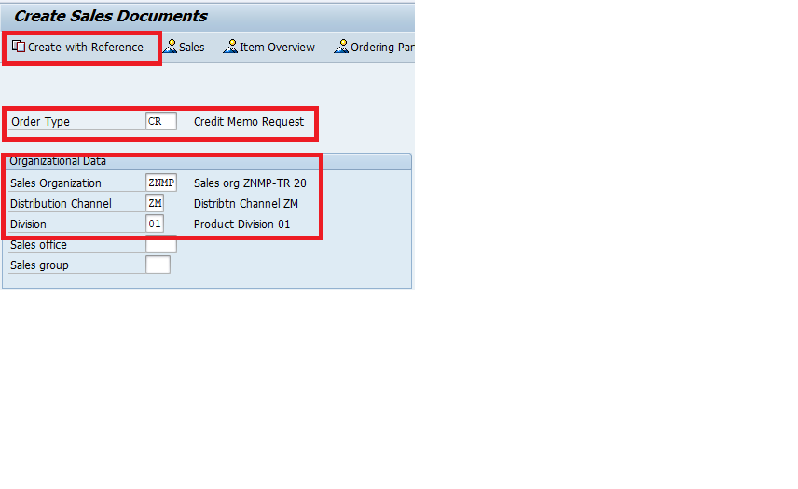

Step 2)
- Enter the billing document no.>>>Press enter>>>Enter Qty>>>complete the document>>>Remove billing block>>>Save the document
- Copy the document no.

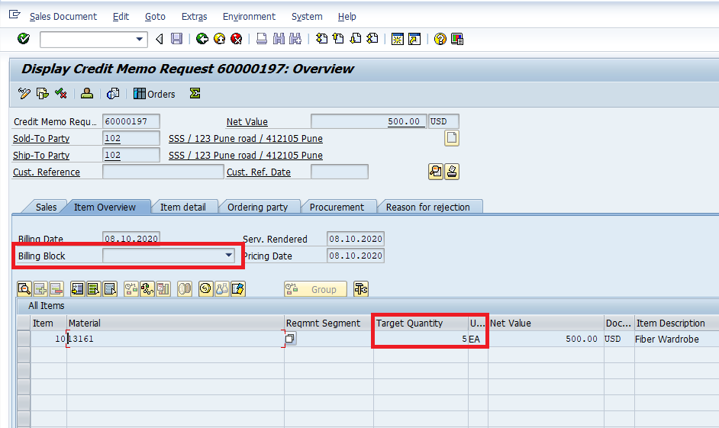

Step 3)
- Enter VF01 in the command field
- Press Enter
- Enter the document no.
- Click on Save

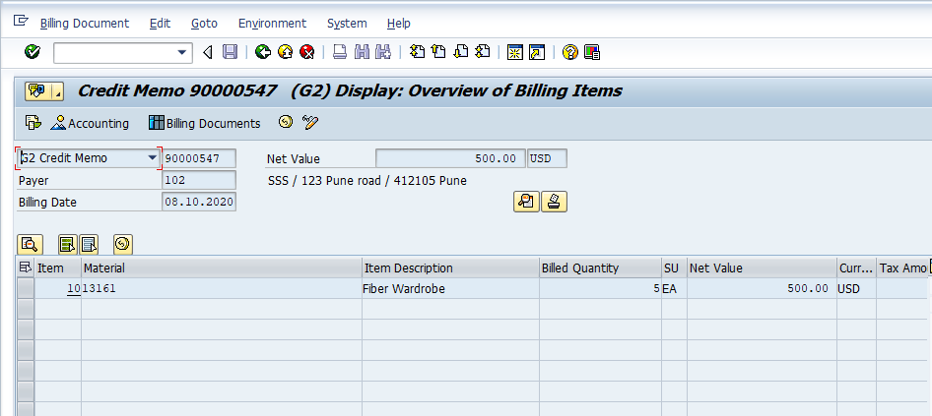

Lab 9-1 Setup up Partner Determination Z# in BP and Normal Sales Order
Step 1)

Path
- SPRO>>>SD>>>Basic Functions>>>Set up partner determination>>>Set Partner Determination for Customer Master

- Partner functions>Position>>Enter SP>>>Copy Sold to party>>>Enter partner function>>>Name>>>Unchecknthe checkbox>>>Enter>>>Enter>>>Save>>>Transport Request

- Now go to Account Group>>>Function assignment>>>Click on new entries>>>Put your Partner Function>>>Account as DEBI>>>Enter>>>Save

- Select the line item AG>>>Sold to party>>>Partner functions in procedure>>>New entries>>>Enter Partner Function>>>Enter>>>Save

- Go back>>>Select Set up Partner determination for SD Header>>>Enter>>>Select line item TA (Standard order)>>>Double click on Partner Function in Procedure>>>New entries>>>Enter your Partner Function>>>Save>>>Transport Request

- Open another session and Enter the T-Code BP>>>Enter Customer no.>>>Enter>>>Select Role as Customer>>>Sales and distribution Tab>>>Partner Function>>>Go to change mode>>>Enter PR>>>Enter>>>Save

Step 2)

Create Sales Order

- Enter the T-code VA01 in the command field
- Enter Order Type (the one you have created in SPRO)
- Enter Sales Area data in Organizational Data Block.
- Press Enter Button
- Enter Details>>>EnterMaterial>>> Enter Qty>>>Check the Incompletion Log>>>Go to>>>Header>>>Sales>>>Partner Tab>>>Check>>>Save

Lab 10-1 Setup Output Determination for Normal Sales Order
Step 1)

Path
- SPRO>>>Sales &Distribution>>>Basic functions>>>Output Determination>>>Output Determination>>>Output Det. Using Condition type>>>Maintain output det. for sales doc.>>>Maintain output types

- Copy BA01>>>Go to change mode>>>Change the name>>>Default values(Tab)>>>4(send immediately)>>>Enter>>>Copy all>>>EN>>>Enter>>>Continue

- Select your output type>>>Click on partner function>>>New entries>>>1 Print output>>>Function>>>Enter>>>Save>>>Transport Request

- Go back>>>Go to maintain output det. procedure>>>V10000(Order Output)>>>Control data>>>Copy>>>Enter the correct counter no.>>>output type>>>Enter>>>Save

Step 2)
- Enter T-code VV11 (Create Output) in the command field
- Enter Output Type as BA__
- Press Enter Button
- Enter Customer no.>>>Function>>>EN>>>Enter>>>Save

Step 3)
Create Sales Order

- Enter the T-code VA01 in the command field
- Enter Order Type (the one you have created in SPRO)
- Enter Sales Area data in Organizational Data Block.
- Press Enter Button
- Enter Details>>>EnterMaterial>>> Enter Qty>>>Check the Incompletion Log>>>Go to extras>>>Output header>>>Edit>>>Enter the output type BA__>>>Medium print>>>Enter>>>Save>>>Logical destination(Type: LP01)

Step 4)
- Enter the T-Code VA02>>>Check the Header>>>Edit>>>Green
- Go back>>>go to extras>>>Header>>>Print Preview

Lab 11-1 Setup Text Determination in Normal Sales Order
Step 1)
Path
- SPRO>>>Sales &Distribution>>>Basic functions>>>Text Contro>>>Define and assign Text determination procedure>>>Configure text>>>Sales Document (Header)

- Go on change mode>>>Copy 01>>>Enter2 digit no.>>>Description>>>Enter>>>Copy all>>>Continue>>>Select yours>>>Go to text ID’s Text Procedure>>>Except Header (From)>>>Delete all entries and add two more header>>>Go to new entries>>>Put sequence>>>Save>>>Transport Request

- Go to Text Procedure assignment>>>Postion>>>Search your standard order>>>Select and put Text Data>>>Enter>>>Save

Step 2)

- Go back >>>Select Item (Sales Order)>>>Go to change mode>>>Copy 01 (Sales Item)>>>Enter text procedure>>>Description>>>Enter>>>Copy all>>>Continue>>>Select yours>>>Go to Text ID’sText procedure>>>Delete and enter new entries>>>Save It>>>Transport Request

- Go to Text Procedure assignment>>>Postion>>>Search your Item category>>>Select and put Text Data>>>Enter>>>Save

Step 3)

Create Sales Order

- Enter the T-code VA01 in the command field
- Enter Order Type (the one you have created in SPRO)
- Enter Sales Area data in Organizational Data Block.
- Press Enter Button
- Enter Details>>>EnterMaterial>>> Enter Qty>>>Complete the document>>>Check the Incompletion Log>>>Go to>>>Header>>>Edit>>>Output BA____>>>Enter>>>2P01>>>Save

Step 4)
Enter the T-code VA02 in the command field
Extras>>>Header>>>Print Preview>>>Check the printout

Lab 12-1 Create Incompletion Procedure and remove the Net Weight/Gross weight/Incoterms/Payterms from resp. Sales Order
Step 1)

Path
- SPRO>>>Sales & Distribution>>>Basic functions>>>Log of Incompletion Items
- Define Incompletion Procedure>>>A Sales Header>>>Procedures>>>11 Copy SO>>>Procedure>>>Any one letter>>>Description>>>Fields>>>Delete the fields like Intercome, NetWeight/Gross Weight ,Payment terms>>>Save
- Go back and do for Item also
- Select B Sales Item>>>Procedures>>>Copy Standard Item>>>Enter Procedure>>>Any letter different from Header>>>Description>>>>Fields>>>Delete the fields like Intercomes/Payment Terms>>>Save
- Assign Item Category >>>Save
- Assign Sales order Type>>>Any letter>>>Save

Step 2)
IMG > SD > Basic Functions > Log of Incomplete Items > Define Status Groups

Step 3)
Create Sales Order

- Enter the T-code VA01 in the command field
- Enter Order Type (the one you have created in SPRO)
- Enter Sales Area data in Organizational Data Block.
- Press Enter Button
- Enter Details>>>EnterMaterial>>> Enter Qty>>>Complete the document>>>Check the Incompletion Log>>>Save

Lab 13-1 Create a Material Determination scenario in Sales Order

Step 1)

Path
- SPRO>>>Sales & Distribution>>>Basic functions>>>Material Determination>>>

- Assign Procedures to sales document types>>>Position>>>Sales document type>>>Enter Material Determionation (A00001)>>>Enter>>>Save>>>Transport Request

Step 2)

- Sap Menu>>>Logistics>>>Mater data>>>Products>>>Material Determination>>> OR
Enter VB11 (create) in the Command Field
- Enter Material Det.Type(A001)>>>Enter>>>Change Valid to date>>>Proposal reason>>>Manual material selection>>>Enter 2 Material>>>Enter >>>Save

Step 3)

Create Sales Order

- Enter the T-code VA01 in the command field
- Enter Order Type (the one you have created in SPRO)
- Enter Sales Area data in Organizational Data Block.
- Press Enter Button
- Enter Details>>>Enter Material>>>It will ask different material,Pick it (Substitute)>>>Enter Qty>>>Complete the document>>>Save
Step 4)

Delivery
- Enter T-code VL01N in the command field
- Enter Shipping Point>>>Enter Order no.>>>Enter>>>
- Picking>>>enter the qty>>>Post goods Issue (PGI)

Step 5)

Billing
• Enter VF01 in the command field
• Press Enter
• Enter the document no.
• Click on Save

To Check the document>>> T-code VA02>> Click on Document flow

Lab 14-1 Create Free Goods Scenario in Sales Order
Step1)
SPRO>>>Sales & Distribution>>>Basic Functions>>>Free Goods>>>Determine Item Category for free goods item>>>New Entries>>>Enter>>>Save

ZCST->NORM->FREE->ZTST->TANN

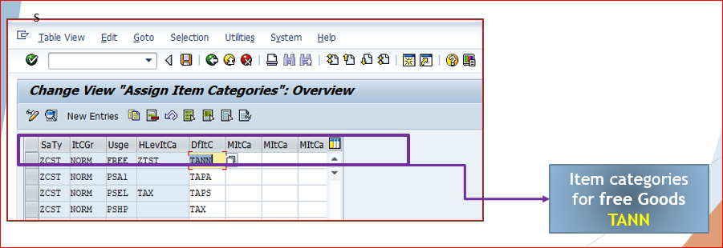

Step 2)

Go to free goods>>>Condition technique for free goods>>>Activate free goods deteminination>>>Postion>>>”A”>>>Add “N”>>>Select free goods>>>Save>>>Transport Request

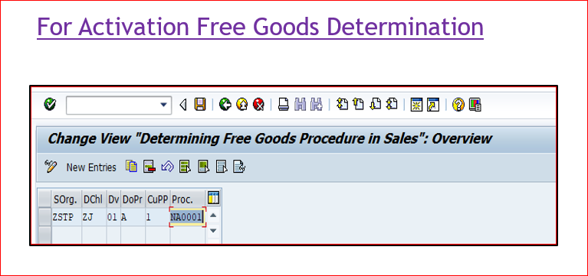

Step 3)
- Enter the T-Code VBN1 (Create Free Goods) OR
SAP Menu>>>Logistics>>>Conditions>>>Free Goods>>Create Free goods
- Enter Dis. Type NA00>>>Enter>>>Change the valid to date>>>Enter Material>>>Qty>>>For (2)>>>EA>>>Qty add(1)>>>Save it
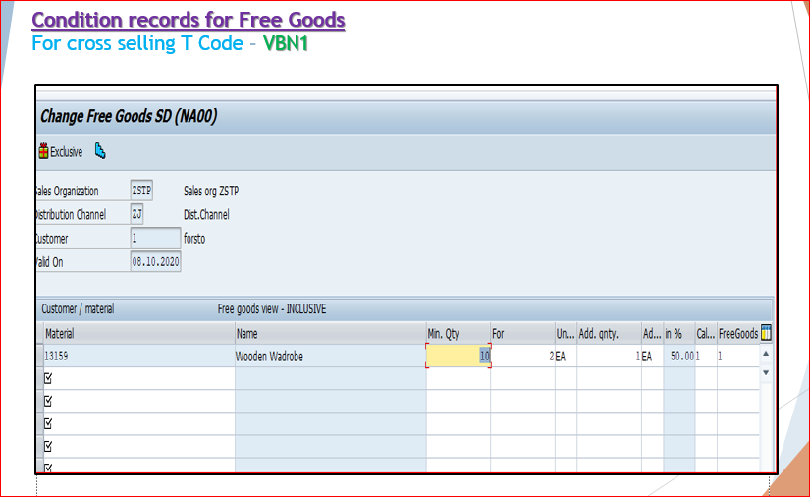
Step 4)
Create Sales Order

- Enter the T-code VA01 in the command field
- Enter Order Type (the one you have created in SPRO)
- Enter Sales Area data in Organizational Data Block.
- Press Enter Button
- Enter Details>>>Two times divided>>>Complete the document>>>Save
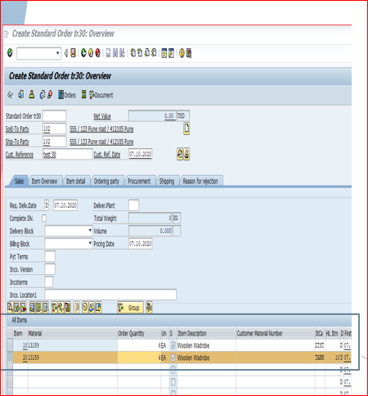
Step 5)
Delivery
- Enter T-code VL01N in the command field
- Enter Shipping Point>>>Enter Order no.>>>Enter>>>
- Picking>>>enter the qty>>>Post goods Issue (PGI)

Step 6)

Billing
• Enter VF01 in the command field
• Press Enter
• Enter the document no.
• Click on Save
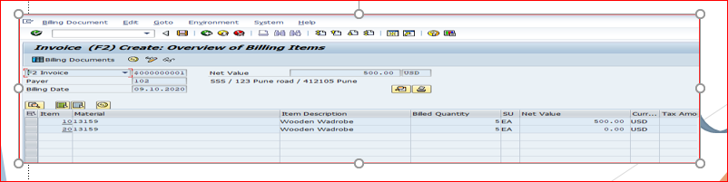
To Check the document>>> T-code VA02>> Click on Document flow

Lab 15-1 Create a Cross Selling Scenario with Sales Order->Delivery->Split Invoice
Step 1)
- Path
SPRO>>>Sales and Distribution>>>Basic functions>>>Cross Selling
- Maintain Customer/Document procedures for cross selling
- Assign document procedure for cross selling to sales document types>>>Position>>>Sales Doc.>>>”B” Cross Selling>>>Save>>>Transport Request
- Define & assign cross selling profile>>>Assign Cross selling Profile>>>New Entries>>>Save>>>Transport Request
Sales org->Dhl->Div->CS Cust. Pro.-> CS Doc. Pro>>> CS Profile

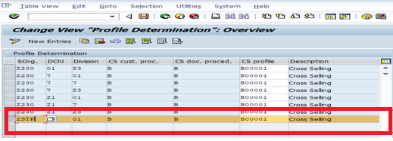

Step 2)
- Path
- SPRO>>>Sales and Distribution>>>Sales>>>Sales document>>>Sales document Item>>>
- Assign Item Categories>>>New Entries>>>Enter>>>Save>>>Transport Request
ZC20->NORM>>>CSEL>>>ZT20>>>ZT20

Step 3)
- Enter the T-Code VB41 (to create cross selling) in thed command field
- Enter CS01(Cross selling)>>>Enter>>>Valid to date>>> 1st Material>>>2nd Material>>>Save
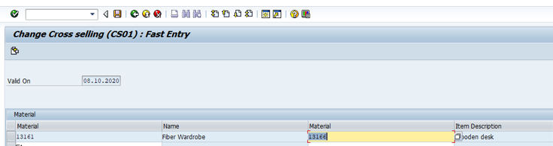

Step 4)

- Enter the T-Code BP in the Command field.
- Enter the Customer no. >>>Press Enter>>>Select Role as Customer Role>>>Go to change mode>>>Enter PP customer Proce. “B” (Cross Selling)>>>Save

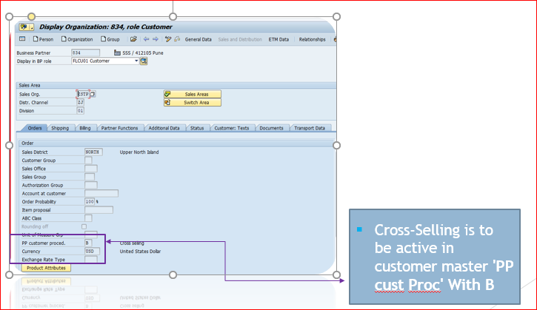

Step 5)
Create Sales Order

- Enter the T-code VA01 in the command field
- Enter Order Type (the one you have created in SPRO)
- Enter Sales Area data in Organizational Data Block.
- Press Enter Button
- Enter Details>>>Enter material>>>It will pop two materials>>Copy>>>Enter Qty>>>Complete the document>>>Save

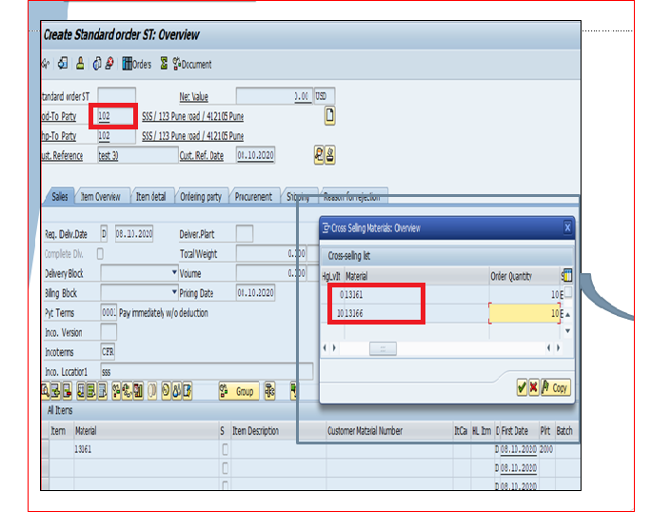

Step 6)

Delivery
- Enter T-code VL01N in the command field
- Enter Shipping Point>>>Enter Order no.>>>Enter>>>
- Picking>>>enter the qty>>>Post goods Issue (PGI)

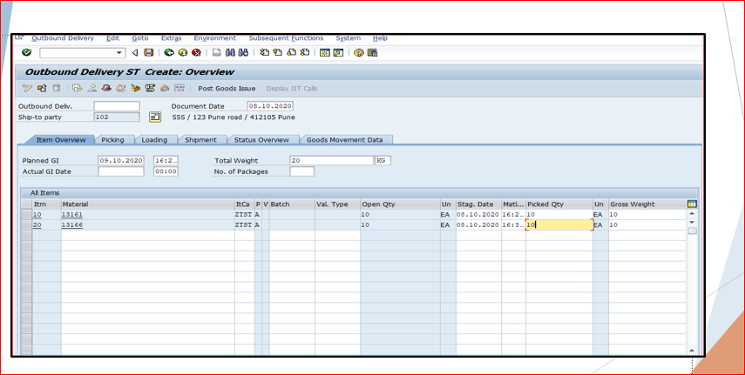

Step 6)

Billing
• Enter VF01 in the command field
• Go to selection list>>>Select 1st one>>>Copy
• Press Enter
• Click on Save

Create 2nd Billing

• Enter VF01 in the command field
• Press Enter
• Enter the document no.
• Click on Save

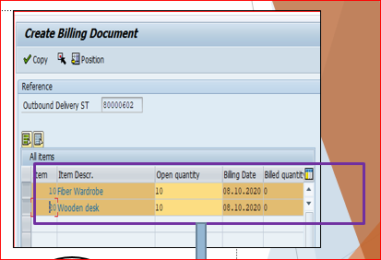

To Check the document>>> T-code VA02>> Click on Document flow

Lab 16-1 Create a New Availability Check Group->Assign to Material Master->Create Sales Order->Delivery
1.1 Create a New Availability Check Group
Path
SPRO>>>SAP IMG>>>Sales & Distribution>>>Basic Function>>>Availability check & transfer of requirements>>>Availability check>>>Availability check with ATP Logic or Again. Planning

Step 1)
Define Availability check group>>>Copy “02” >>>Change the AV as “ZN” or anything else>>>Save>>>Transport Request

Step 2)
Configure scope of Availability check>>>Copy the standard one (A) “02”>>>Avail . name as ZN>>>Save>>>Transport Request

Step 3)
Configure scope of Availability check>>>Copy the standard one for Delivery (B) “02” >>>Avail. name as ZN>>>Save>>>Transport Request

  - Assign to Material Master

- Enter the T-Code MM02 (Change Material) in cammand field
- Enter the Material>>>Select veiw as Sales: General & Plant Data>>>Change availabilty check from 02 to ZN>>>Save

  - Create Sales Order

Step 1)
- Enter the T-code VA01 in the command field
- Enter Order Type (the one you have created in SPRO)
- Enter Sales Area data in Organizational Data Block.
- Press Enter Button

Step 2)
Enter Sold-to-party>>>Material>>>Enter qty>>>fill all the mandatory details>>>Check in procurement Rq. Ty. as 011>>>go on display availability check >>>Check availability check as “ZN” that you have created>>>Check rule as “A”>>> Check the incompletion log>>>Save

  - Delivery

Enter T-code VL01N in the command field
Enter Shipping Point>>>Enter Order no.>>>Enter>>>
Picking>>>enter the qty>>>Post goods Issue (PGI)
To Check the document>>> T-code VA02>> Click on Document flow

Lab 17-1 Create process flow-CF->CI->CR-CP

Consignment Fillup>>>Consignment Issue>>>Consignment Returns>>>Consignment Pickup

Note: Change the availability check in Materail MM02 as “02” Availbility check in Sales: General & Plant view

- Consignment Fillup
- Check Stock First>>>Enter the T-code MMBE in command field>>>Enter the material>>>Excute

Create Sales order for Consignment Fillup
Step 1)
- Enter the T-code VA01 in the command field
- Enter Order Type as KB (Consignment Fillup)
- Enter Sales Area data in Organizational Data Block.
- Press Enter Button

Step 2)
- Enter Sold-to-party>>>Material>>>Enter qty>>>fill all the mandatory details>>> Check the incompletion log>>>Save

Delivery
- Enter T-code VL01N in the command field
- Enter Shipping Point>>>Enter Order no.>>>Enter>>>
- Picking>>>enter the qty>>>Post goods Issue (PGI)

- Consignment Issue
- Check Stock First>>>Enter the T-code MMBE in command field>>>Enter the material>>>Excute
Create Sales order for Consignment Issue

Step 1)
- Enter the T-code VA01 in the command field
- Enter Order Type as KE (Consignment Issue)
- Enter Sales Area data in Organizational Data Block.
- Press Enter Button

Step 2)
- Enter Sold-to-party>>>Material>>>Enter qty>>>fill all the mandatory details>>> Check the incompletion log>>>Save

Delivery
- Enter T-code VL01N in the command field
- Enter Shipping Point>>>Enter Order no.>>>Enter>>>
- Picking>>>enter the qty>>>Post goods Issue (PGI)

Billing
• Enter VF01 in the command field
• Press Enter
• Enter the document no.
• Click on Save

- Consignment Returns
- Check Stock First>>>Enter the T-code MMBE in command field>>>Enter the material>>>Excute
Create Sales order for Consignment Returns

Step 1)
- Enter the T-code VA01 in the command field
- Enter Order Type as KR (Consignment Returns)
- Enter Sales Area data in Organizational Data Block.
- Press Enter Button

Step 2)
- Enter Sold-to-party>>>Material>>>Enter qty>>>Remove the billing block>>>Enter the order reason>>>fill all the mandatory details>>> Check the incompletion log>>>Save

Delivery
- Enter T-code VL01N in the command field
- Enter Shipping Point>>>Enter Order no.>>>Enter>>>
- Picking>>>enter the qty>>>Post goods Issue (PGI)

Billing
• Enter VF01 in the command field
• Press Enter
• Enter the document no.
• Click on Save

- Consignment Pickup
- Check Stock First>>>Enter the T-code MMBE in command field>>>Enter the material>>>Excute
Create Sales order for Consignment Pickup
Step 1)
- Enter the T-code VA01 in the command field
- Enter Order Type as KA (Consignment Pickup)
- Enter Sales Area data in Organizational Data Block.
- Press Enter Button

Step 2)
- Enter Sold-to-party>>>Material>>>Enter qty>>>fill all the mandatory details>>> Check the incompletion log>>>Save

Delivery
- Enter T-code VL01N in the command field
- Enter Shipping Point>>>Enter Order no.>>>Enter>>>
- Picking>>>enter the qty>>>Post goods Issue (PGI)

Lab 18-1 Normal Sales order (Optional)->Returns->Subsequent Deivery (type-SD)->Delivery
  - Create a Normal Sales Order

Step 1)
- Enter the T-code VA01 in the command field
- Enter Order Type (the one you have created in SPRO)
- Enter Sales Area data in Organizational Data Block.
- Press Enter Button

Step 2)
- Enter Sold-to-party>>>Material>>>Enter qty>>>fill all the mandatory details>>> Check the incompletion log>>>Save

Delivery
- Enter T-code VL01N in the command field
- Enter Shipping Point>>>Enter Order no.>>>Enter>>>
- Picking>>>enter the qty>>>Post goods Issue (PGI)

Billing
• Enter VF01 in the command field
• Press Enter
• Enter the document no.
• Click on Save

  - Create Returns with reference of above sales order

Step 1)
- Enter the T-code VA01 in the command field
- Enter Order Type RE (Returns)
- Enter Sales Area data in Organizational Data Block.
- Press Enter Button

Step 2)
- Enter qty the qty you want return >>> Check the incompletion log>>>Save

  - Create Subsequent Deivery

Step 1)
- Enter the T-code VA01 in the command field
- Enter Order Type SD Subsequent Deivery
- Enter Sales Area data in Organizational Data Block.
- Press Enter Button
- Enter Return Sales order no.

Step 2)
- Check the incompletion log>>>Save

Delivery
- Enter T-code VL01N in the command field
- Enter Shipping Point>>>Enter Order no.>>>Enter>>>
- Picking>>>enter the qty>>>Post goods Issue (PGI)

To Check the document>>> T-code VA02>> Click on Document flow

Lab 19-1 Create a 3rd Party Sales Order->Purchase Order->GR
Step 1)
- Enter T-Code MM02 in the Command Field.
- Enter Material>>>Select View as>>> Sales: Sales org data and Sales: General/Plant>>>Change the item category group from “NORM” to “BANS” (Third party item)>>>Save
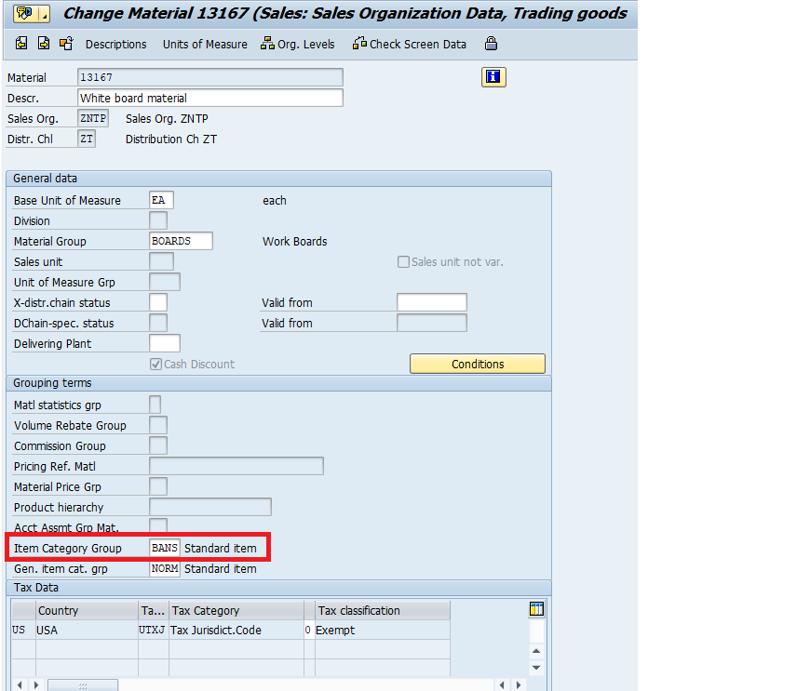
Step 2) Configuration
Path
- SPRO>>>Sales and Distribution>>>Sales document>>>Sales Item category>>>TAS (Third party item)
- Assign Item category>>>Search Sales document type in position>>>
ZCNT->BANS->TAS->TANN->TAW
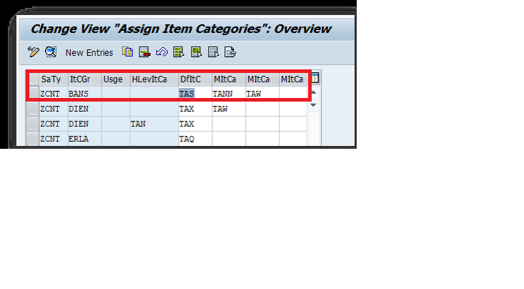

Step 3)
- SPRO>>>Sales & Distribution>>>Billing>>>Billing Document>>>Maintain Copy Control>>>Billing type as “F2”>>>Sales document ZC20>>>Select the standard one and go to item>>>Select TAS>>>Go to display>>>Billing quantity “F”>>>Save
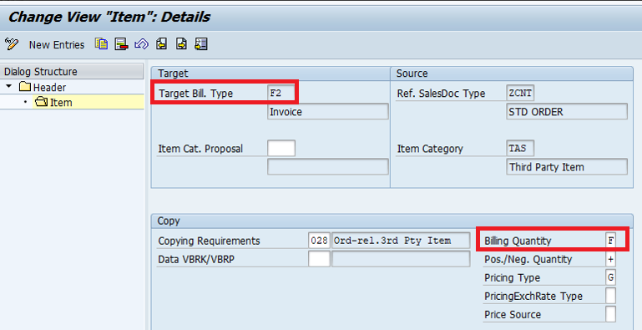

Step 4)
- Enter the T-code VA01 in the command field
- Enter Order Type (the one you have created in SPRO)
- Enter Sales Area data in Organizational Data Block.
- Press Enter Button
- Enter Sold-to-party>>>Material>>>Enter qty>>>Check item category as TAS>>>Enter Plant>>>Purchase req.>>>Enter price>>>fill all the mandatory details>>> Check the incompletion log>>>Save
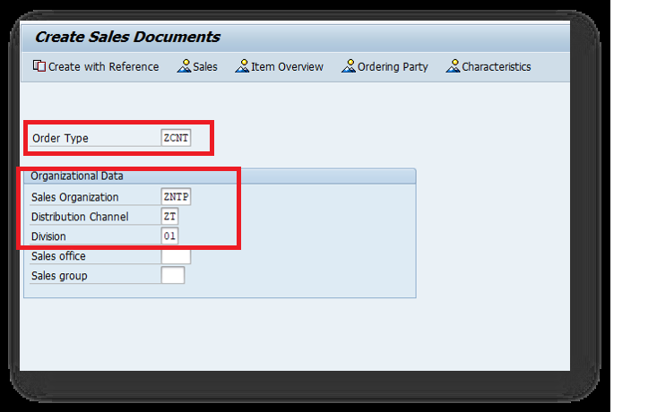

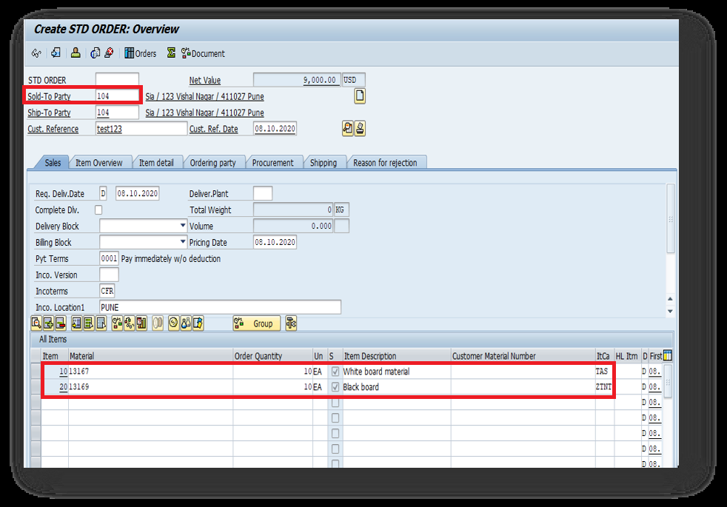

Step 5)
- Enter the T-Code VA02 in the Command field.
- Click on document flow>>>Select & go in Status overview>>>Copy Purchase requisition no.

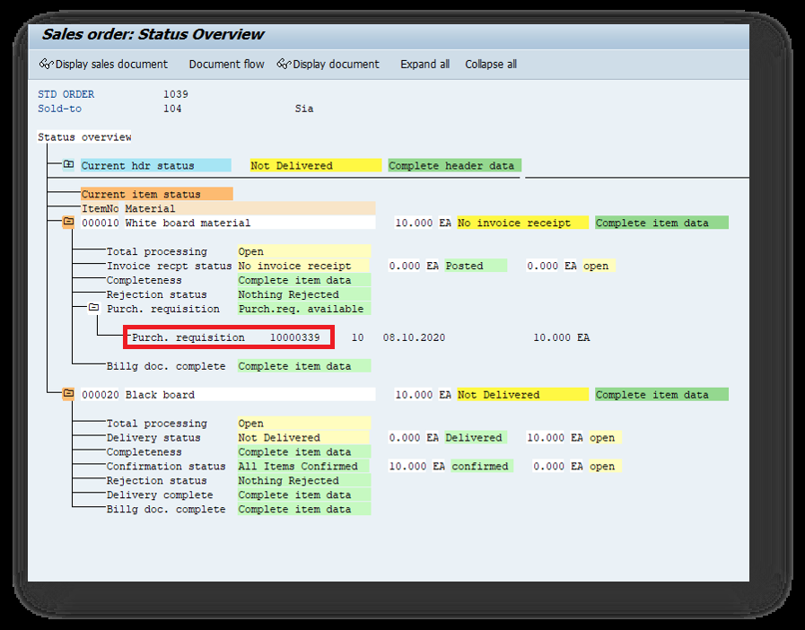

Step 6)
- Enter the T-Code ME21N in the Command field.
- Document Overview>>>Purchase Requisition>>>Excute>>>Drag and put the no. to the shopping cart
- Enter Purchase org>>>Vendor>>>Enter Gl Account>>> Check>>>Save

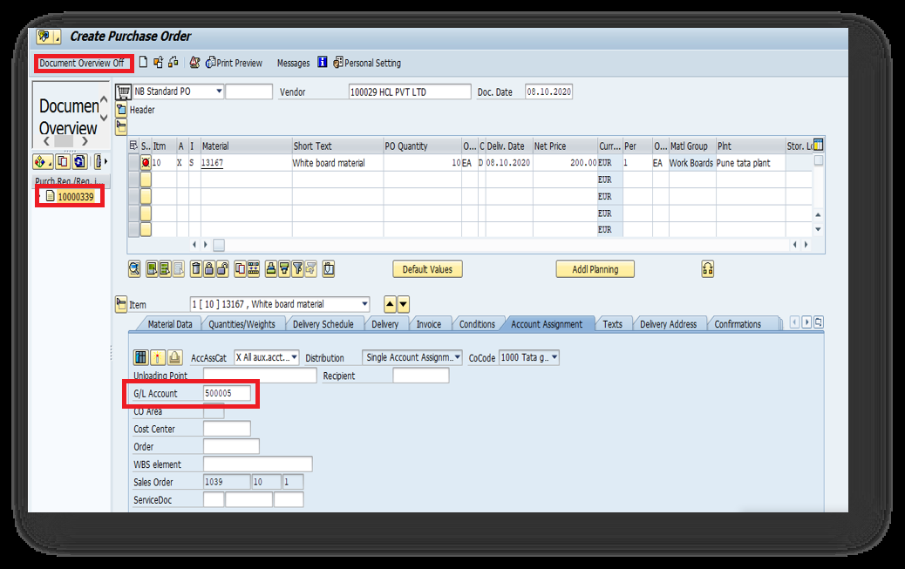

Step 7)
- Enter the T-Code MIGO in the command field.
A01>>R01 Purchase Order
- Enter Purchase order no. from last step>>>Enter>>>Check on Item Ok >>>Check>>>Post
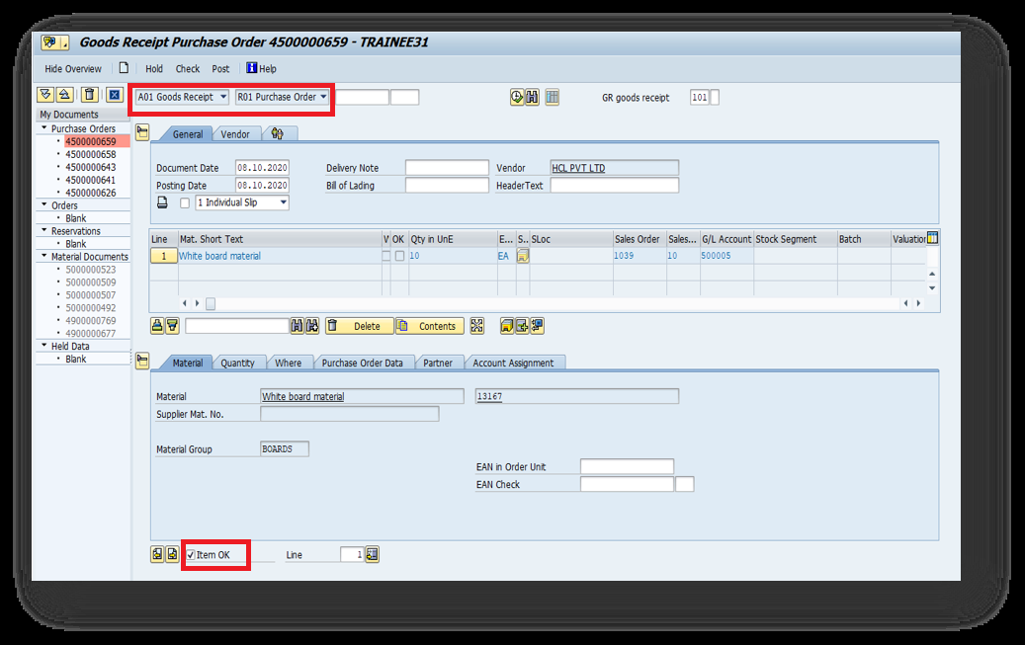
Step 8)

- Enter the T-Code MIRO in the command field
- Enter the company code
- Enter Purchase order no.>>>Invoice Date>>>Amount>>>Tax code>>>Tax>>>Baseline date>>>Remove the Tax V1

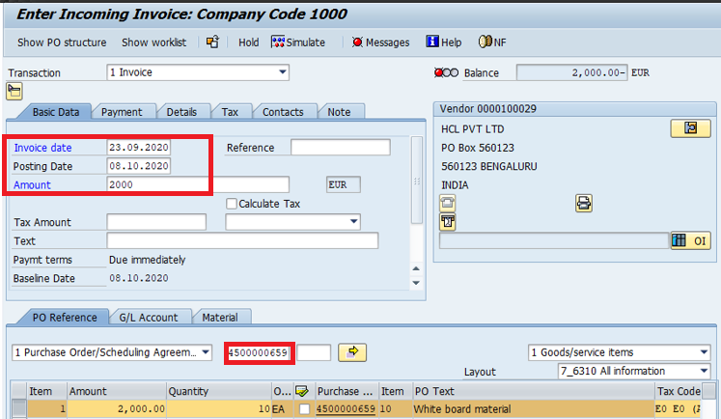

Step 9)
Billing
• Enter VF01 in the command field
• Press Enter
• Enter the document no.
• Click on Save

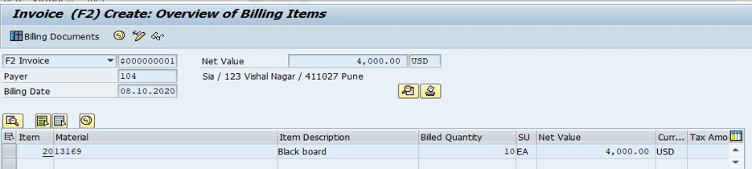

Step 10)
To Check the document>>> T-code VA02>> Click on Document flow

